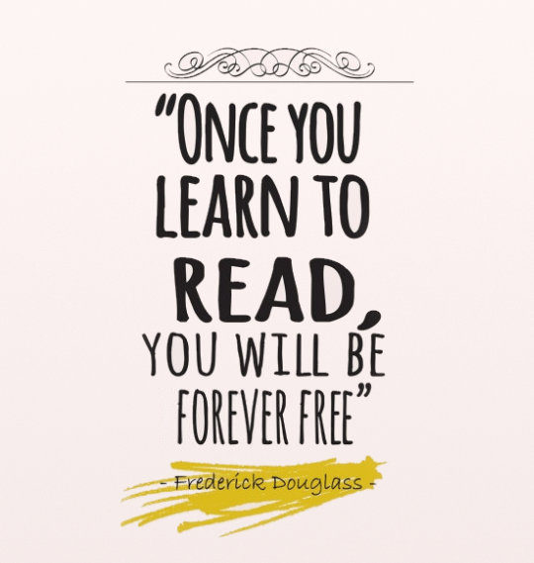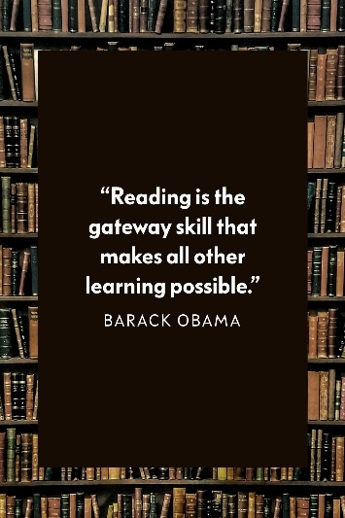  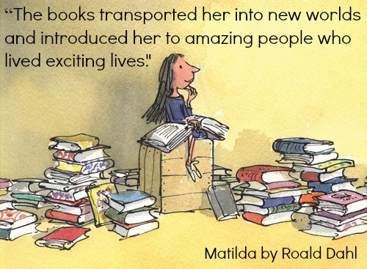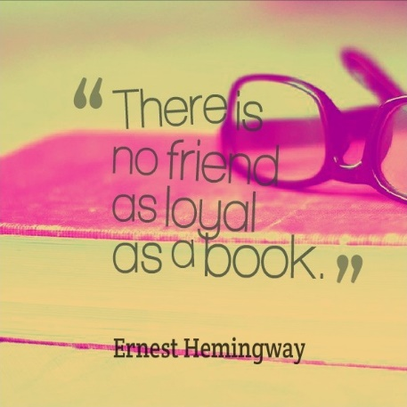  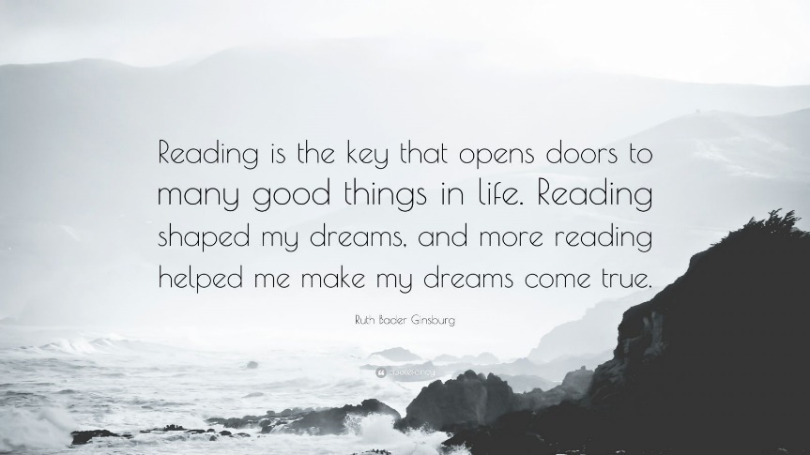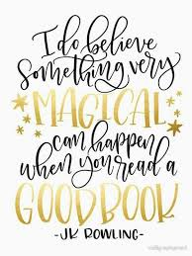 |   An Ossie’s guide to home reading  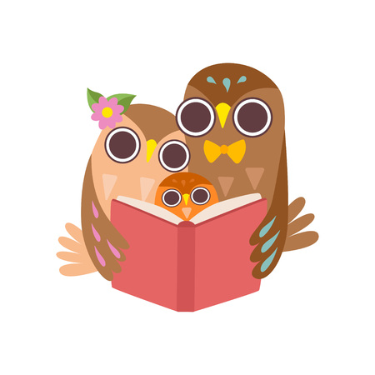
What makes a good reader?  At St Osmund’s CE Middle School, we aim to develop fluent readers with rich vocabularies who fully comprehend a variety of texts whilst at the same time instilling a life-long thirst for reading.  Why read?  - Children who read daily, achieve better at age16 academically.  - Regular reading and positive mental health are linked.  - Pupils are more likely to master other curriculum areas if they can read well.  How much?  We read in school every day as part of lessons as well as for pleasure and in the wider curriculum.  We ask that all pupils read at home for a minimum of 20 minutes 5 x a week. | How can I help my child to become a successful reader?  Reading consists of four strands…  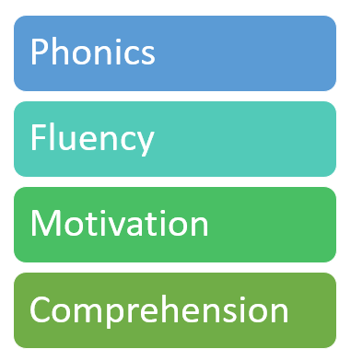  In the following pages of this guide we will give you some TOP TIPs to support each of these strands at home:

  Listen to your child read daily. If your child stumbles on a word, encourage them to sound it out. But if they still can't get it, provide the word so they don't get discouraged.  Use the sound not the letter names. At first school, children are taught to pronounce each letter with a very ‘pure’ sound – so the letter ‘p’, for instance, is pronounced with a popping sound, as just ‘p’, not ‘puh’, and ‘s’ is pronounced like a hiss, not ‘suh’.  Stuttering out the initial sound of a word in order to drawing their attention to it: Please can you pass the j j j jam. Please can you get in the c c c car. You can play games with this, too, where they have to guess what you are going to say just by the initial sound, for example: 'Put your finger on your n n n... (pause to let them guess!) nose' or 'Would you like to eat a b b b... (banana)?  Find lots of alliteration opportunities (alliteration is when words start with the same sound), for example: Daisy and Danny are dancing in the dark. It’s also fun to think of alliteration names for all your friends and family (how about Marvellous Mummy and Delicious Daddy?).  Drawing their attention to the logos they recognise and then helping them find other things that start with this letter (for example, 'Tesco starts with a t t t. What else can you think of that starts with a t t t?').  When shopping, encourage your child to look at the labels on food or to help you write the initial sound of a word on a shopping list ('I need 3 things that start with a b (banana, bread and broccoli), so please can you write me 3 bs on the list?'). |   The more often your child hears fluent reading, the more likely she/he is to pick it up him/herself. Start by reading a paragraph or a full page from a book, and then ask your child to read it. When you provide that model, it’s an opportunity for the child to get familiar with the story, understand the pacing, and then mimic you.  Running your finger under words as you read them — comes in handy. You can track while you’re reading to your child or ask her to track when she’s reading out loud.  Choral reading simply means you read a story out loud and ask your child to read along with you at the same pace. This helps him/her understand what fluent reading feels like and gives him the chance to practice it himself at your pace.  Set up an inviting stage for them to practice reading stories out loud by creating an audience out of their favourite stuffed animals or recruiting your family pet to listen along.  Every so often, when your child is reading out loud, record a passage and then listen to it together.  Sight words – these are the words which can not be decoded using phonics. Focus on encouraging your child to retain these once they have been given them.
  Spread the joy - Show your child how much you value reading by having plenty of books and magazines around the house.  Pick your moment - Choose a time when your child’s not too tired and find a quiet place where they won’t be distracted by screens (or by noisy brothers or sisters!).  Don’t stop - Even when your child is becoming a good independent reader, keep on reading to them! Stories and high-quality non-fiction are important – and so is the cuddly quiet time you spend together sharing them!  Keep it brief - Keep reading sessions short and focused, and stop if your child is tired or fed up. A short, happy reading session is so much better than a long, difficult one!  You are the key ingredient - Your response or feedback has a strong effect on how hard they will try to become good readers. Always remember to give them genuine praise for their efforts.  Take advantage of tech- Technology is changing the way we all learn, and it can have a positive impact on kids and their reading. By adding reading on a tablet into the mix it can raise self-esteem and interest. |   KS2 children will receive a bookmark with appropriately challenging comprehension questions you can discuss as part of your reading session.  It is always useful to think of a session as having 3 parts:  - Before: "What are you interested in about this book? What doesn't interest you?"  - During: "What's going on in the book? Is it turning out the way you thought it would? What do you think will happen next?"  - After: "Can you summarise the book? What did you like about it? What other books does it remind you of?"  Encourage your child to answer the questions in full sentences. Eg. In answer to what books does it remind you of? Your child would say “This books reminds me of … because…” rather than just giving a book title.

